天海分拣系统上传数据至创联仓储系统改造上线说明书
- 前言
1、编写目的
根据国家烟草局要求；分拣数据可以时时上传国家局的指示，对天海分拣系统进行相应的改造已完成.现以下做相应具体说明，方便天海实施人员对已实施的系统进行相应的改造。
2、背景说明
软件名称：TH分拣系统
项目提出：湖南省烟草公司；
项目开发：天海欧康（陕西全省）；
接口需求：创联．
3、定义

4、参考资料
《商业企业物流配送中心数字仓储管理系统标准数据交换接口明细表（分拣系统用）》
- 实施步骤
1、选择主机；
2、新建数据库XTHOutCL；
3、执行 SQL脚本执行程序/数据库更新脚本.exe如下图示
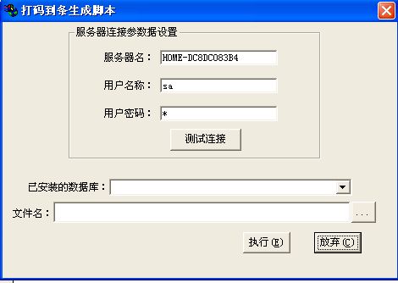
4、主机》测试连接通过后，选择已安装的数据库；如下图示
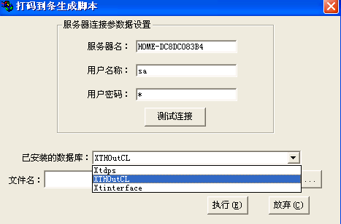
5、选取执行文件
（注：烟草公司只有一条线，选chuanlian1.sql; 二条分拣线选chuanlian2.sql）; 三条选chanling3.sql)
选取前先记事本打开文本代码及修改并保存示例如下：（以二条分拣线为例）chuanlian2.sql
CREATE VIEW ThOne
1表示标签分拣线
2表示半自动分拣线
AS

SELECT a.PicklineID AS SORTING_CODE, a.PicklineName AS SORTING_NAME,
2 AS SORTING_TYPE,a.IsValid AS ISACTIVE, LEFT(b.ImportTime, 14)
AS UPDATE_DATE, 0 AS IS_IMPORT
修改指定分拣线1数据库主机IP; USER ID; PASSWORD;
FROM OPENDATASOURCE(
'SQLOLEDB',
'DATA SOURCE=192.168.1.63; USER ID=sa;PASSWORD=sa'
).XTDPS.DBO.BS_PICKLINEINFO a LEFT JOIN
修改指定分拣线1数据库主机IP; USER ID; PASSWORD;
OPENDATASOURCE(
'SQLOLEDB',
'DATA SOURCE=192.168.1.63; USER ID=sa;PASSWORD=sa'
).XTDPS.DBO.PI_BORROW_MASTER b ON a.PICKLINEID=b.PICKLINEID

GO
1表示标签分拣线
2表示半自动分拣线
CREATE VIEW Thtwo
AS
SELECT a.PicklineID AS SORTING_CODE, a.PicklineName AS SORTING_NAME,
2 AS SORTING_TYPE,a.IsValid AS ISACTIVE, LEFT(b.ImportTime, 14)
AS UPDATE_DATE, 0 AS IS_IMPORT
修改指定分拣线2数据库主机IP; USER ID; PASSWORD;
from
OPENDATASOURCE(
'SQLOLEDB',
'DATA SOURCE=192.168.1.156; USER ID=sa;PASSWORD='
).XTDPS.DBO.BS_PICKLINEINFO a LEFT JOIN
修改指定分拣线2数据库主机IP; USER ID; PASSWORD;
OPENDATASOURCE(
'SQLOLEDB',
'DATA SOURCE=192.168.1.156; USER ID=sa;PASSWORD='
).XTDPS.DBO.PI_BORROW_MASTER b ON a.PICKLINEID=b.PICKLINEID
GO
CREATE VIEW dbo.DWV_IDPS_SORTING
AS
SELECT * FROM THONE
UNION
SELECT * FROM THTWO
GO
若市公司有修改指定；改写当地市公司国家编码

CREATE VIEW dbo.THONE_STATUS
AS
SELECT right(BorrowID,10) AS SORT_BILL_ID, CompanyID AS ORG_CODE,
PicklineID AS SORTING_CODE, LEFT(ImportTime, 8) AS SORT_DATE,
Receipts AS SORT_SPEC, cast(TotalQuantity as decimal(8,2)) AS SORT_QUANTITY,
Receipts AS SORT_ORDER_NUM, left(replace(replace(replace(CONVERT(varchar(30),startdate,120),' ',''),'-',''),':',''),14)
AS SORT_BEGIN_DATE, left(replace(replace(replace(CONVERT(varchar(30),enddate,120),' ',''),'-',''),':',''),14) AS SORT_END_DATE,
DATEDIFF(n, StartDate, EndDate)*60 AS SORT_COST_TIME, 0 AS IS_IMPORT
修改指定分拣线1数据库主机IP; USER ID; PASSWORD;
FROM OPENDATASOURCE(
'SQLOLEDB',
'DATA SOURCE=192.168.1.63; USER ID=sa;PASSWORD=sa'
).XTDPS.DBO.PI_Borrow_Master
GO

CREATE VIEW dbo.THTWO_STATUS
若市公司有修改指定；改写当地市公司国家编码

AS
SELECT right(BorrowID,10) AS SORT_BILL_ID, CompanyID AS ORG_CODE,
PicklineID AS SORTING_CODE, LEFT(ImportTime, 8) AS SORT_DATE,
Receipts AS SORT_SPEC, cast(TotalQuantity as decimal(8,2)) AS SORT_QUANTITY,
Receipts AS SORT_ORDER_NUM, left(replace(replace(replace(CONVERT(varchar(30),startdate,120),' ',''),'-',''),':',''),14)
AS SORT_BEGIN_DATE, left(replace(replace(replace(CONVERT(varchar(30),enddate,120),' ',''),'-',''),':',''),14) AS SORT_END_DATE,
DATEDIFF(n, StartDate, EndDate)*60 AS SORT_COST_TIME, 0 AS IS_IMPORT
修改指定分拣线2数据库主机IP; USER ID; PASSWORD;
FROM OPENDATASOURCE(
'SQLOLEDB',
'DATA SOURCE=192.168.1.156; USER ID=sa;PASSWORD='
).XTDPS.DBO.PI_Borrow_Master
GO

CREATE VIEW dbo.DWV_IORD_SORT_STATUS
AS
SELECT * FROM THONE_STATUS
UNION
SELECT * FROM THTWO_STATUS

GO
SET ANSI_NULLS ON
GO
6、执行成功后如下图

7、分拣系统中，确认分拣线编码（基础设置；将两条分拣线分别设为01，02）如下图示
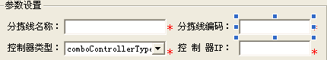

8、将新主机数据库XTHoutCL名，IP，登录用户名，密码转告创联实施人员

要求：分拣线的计算机必须处开机状态，否则视图无效，创联也无法取到相应的数据

注：SQL服务器必须安装企业版本

三、附注
1、该系统改造原理，分拣数据上传必须经过第三方数据库视图组合进行传输。
2、视图传输不影响正常分拣系统。
3、执行前要求：实施人员细心、认真。

